Checkpoint 7: QR Code Recognition with OpenCV
Name: Abhay Tyagi

Tools and Libraries Used
- Python 3
- OpenCV (cv2)
- NumPy
- qrcode library
- pyzbar (for decoding verification)

Code
Step 1: QR Code Generation
A QR code was generated using the qrcode library with high error correction so that it remains readable even after partial damage.
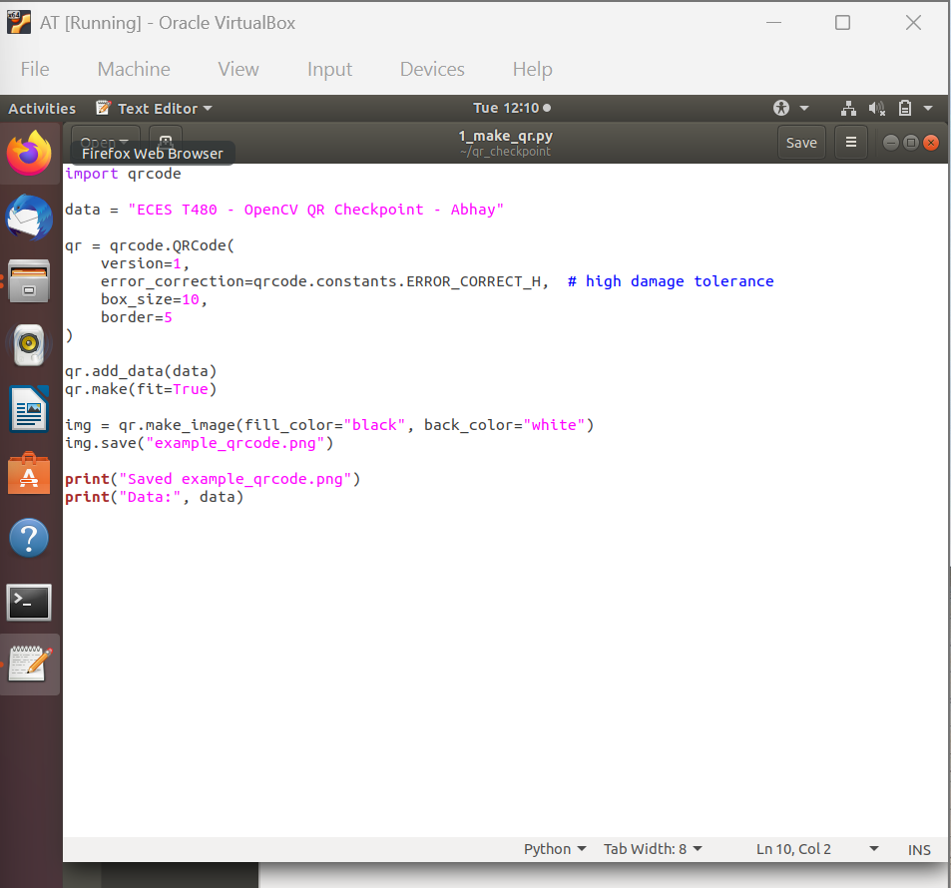

Step 2: QR Code Decoding Using OpenCV
The generated QR code was decoded using OpenCV to verify correctness.
import cv2
img = cv2.imread("example_qrcode.png")
qr = cv2.QRCodeDetector()
data, bbox, _ = qr.detectAndDecode(img)
print("Decoded QR:", data)

Step 3: QR Code Damage Test
To test robustness, a portion of the QR code was covered/erased. Due to high error correction, the QR code was still decoded successfully.
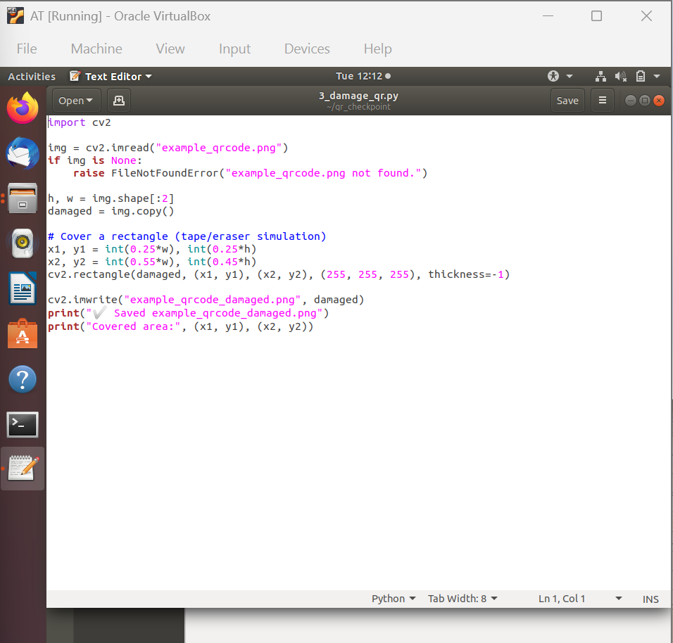

Step 4: Creating a Tilted QR Code
A perspective distortion was applied to simulate a tilted QR code.
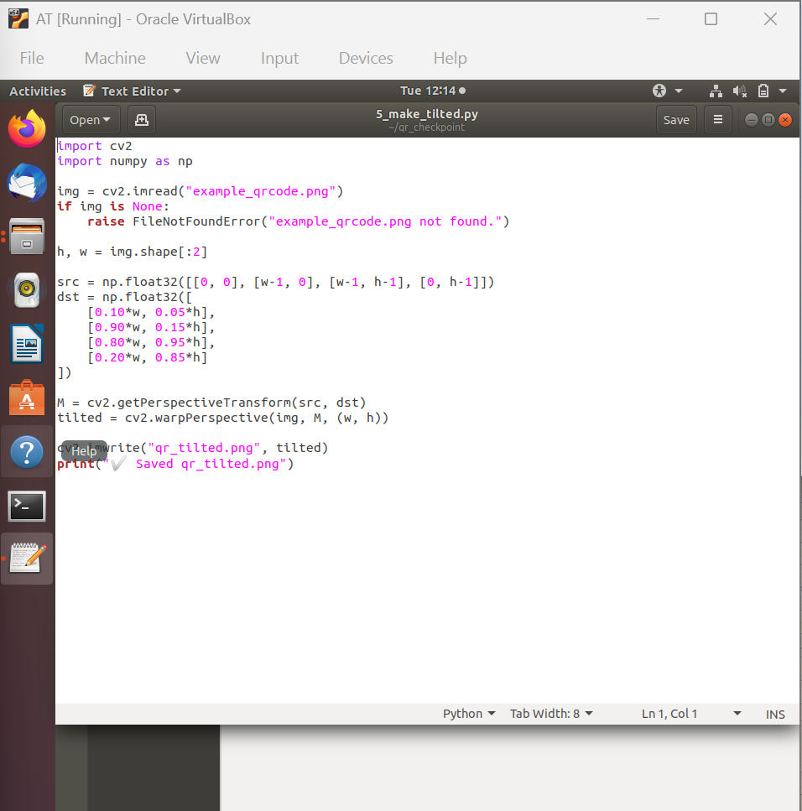

Step 5: Perspective Correction
The corners of the QR code were detected using QRCodeDetector, and a perspective transformation was applied to correct the distortion.
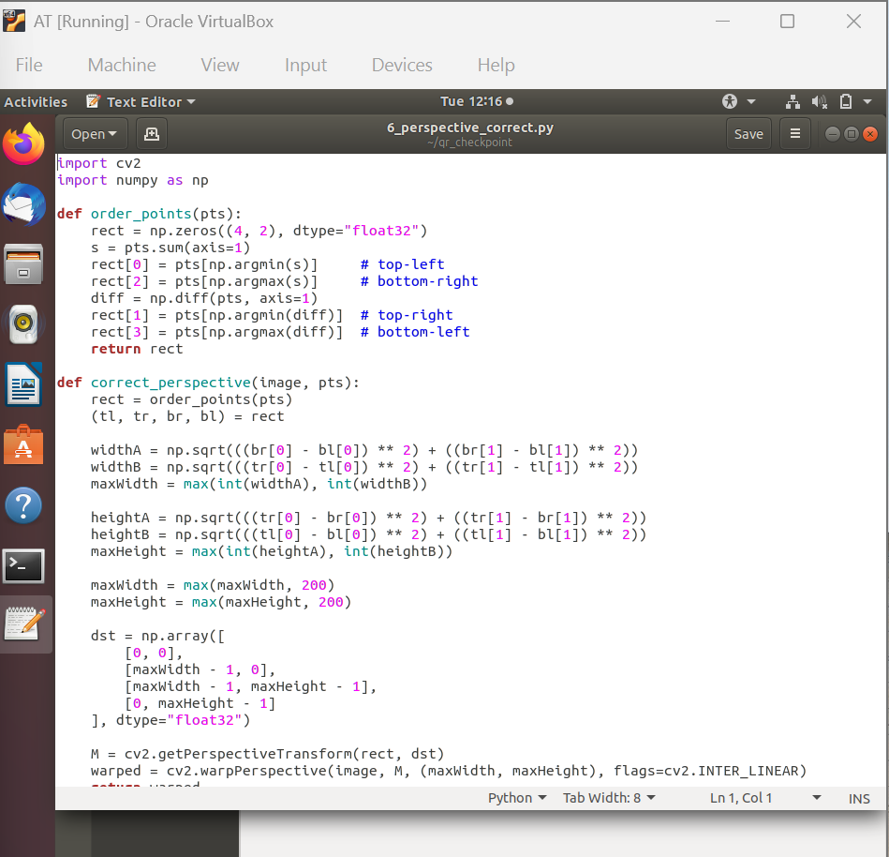

Step 6: Decoding Corrected QR Code
The corrected QR code was decoded again using OpenCV to verify the success of the perspective correction.
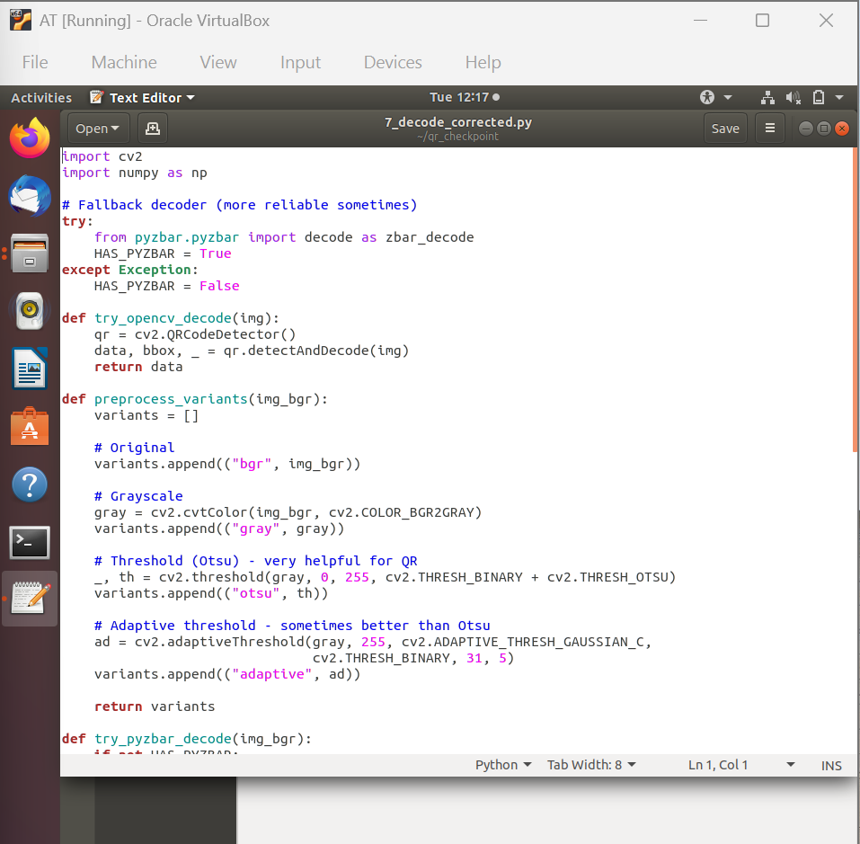

Output
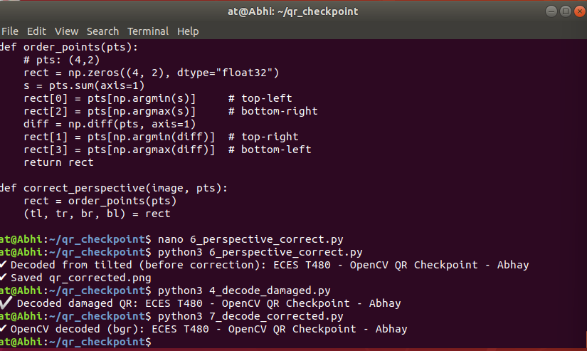
QR-Photos:
